Sport Events Project Report

**Project Description**

**1.Login Screen**

When user in login panel, he/she must enter e-mail & password. If entries not verified by the system. System gives alert and want that informations correctly. When entries are correct, user to be directed events screen by the system.

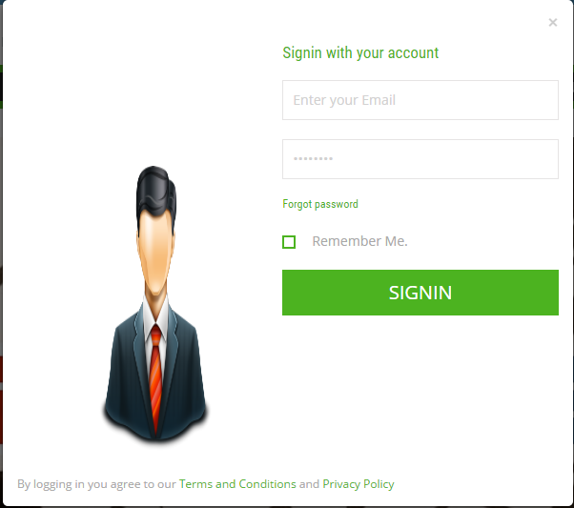

**b)Register Screen**

When user in register panel , there are some information must fill by the user. These informations are : “user name , user surname , e-mail , password ,“. If entered e-mail is saved before in the system , system gives error and user must enter new e-mail. When register operation is complete successfully , new user informations are add to DBMS and user to be directed events screen by the system.

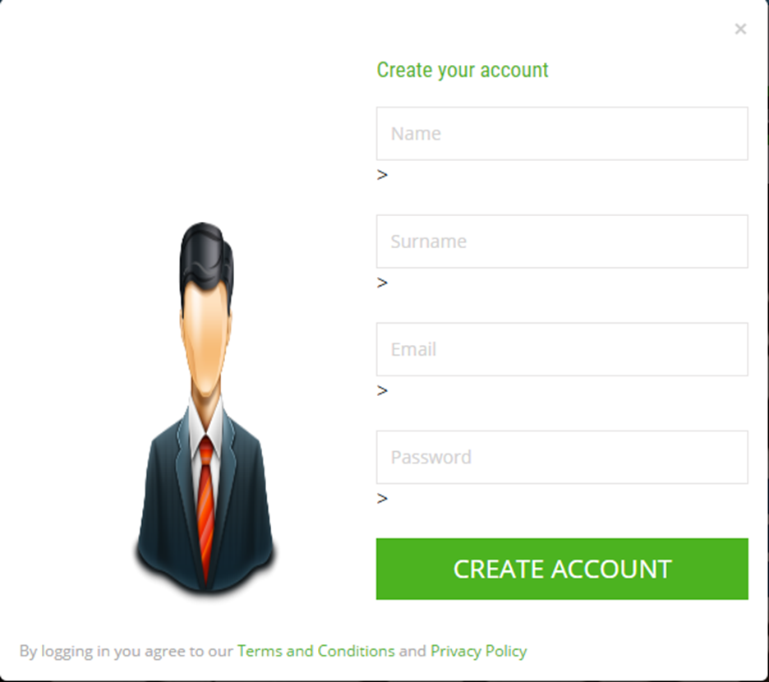

**c)Register Screen (with Webservice )**

User register to buy ticket database system. Entered the name,surname,email,password, phone,city,photo link and username. Then this information add to buy ticket database system.

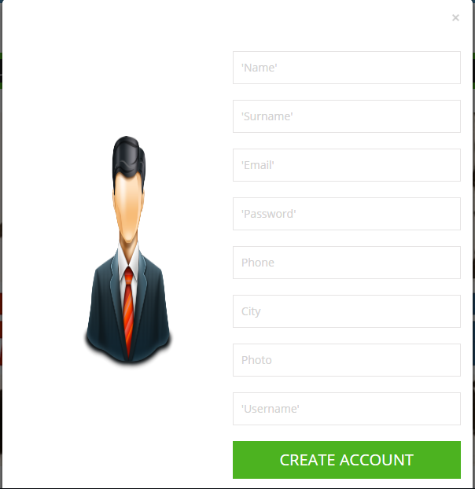

**d)Admin Panel**

When admin want to edit (insert, update , delete ) users. They must be login before want to make a change. Example of Place Table.

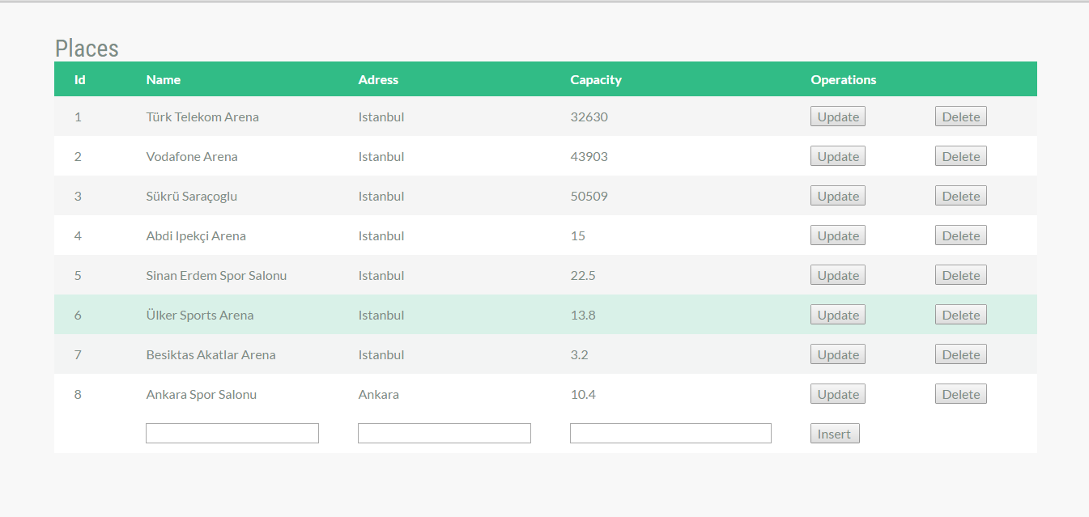

**e)** **User Management**

If User want to change his/her password firstly must be login. Then click to User Management button and change his/her password.

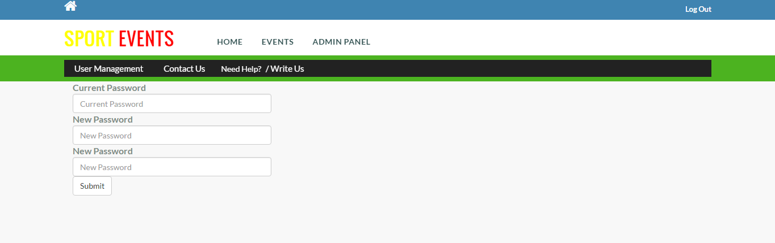

**Screenshot of Project**

**Home Page**



**Sign In with Admin**

Validate login and direct to main page



If admin login Admin Panel button become active

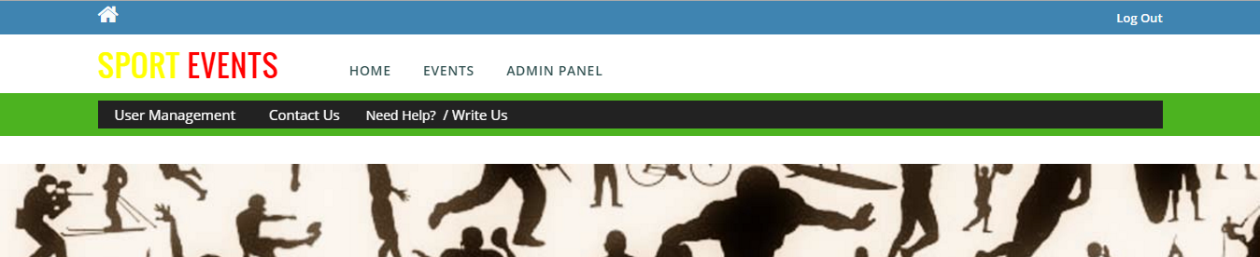

**Events Page**

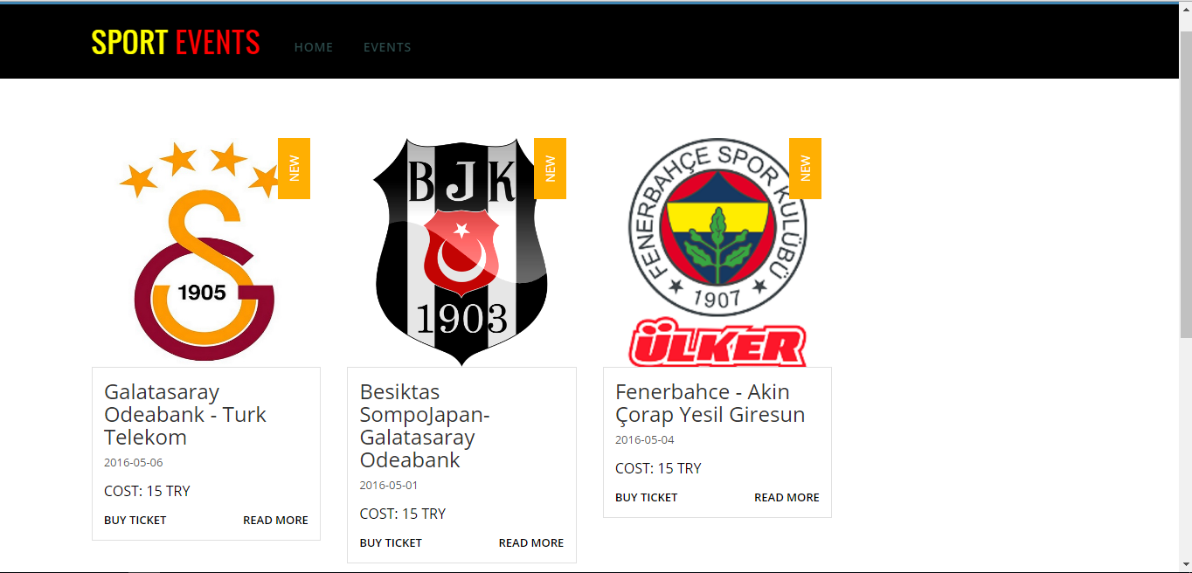

**ER DIAGRAM**

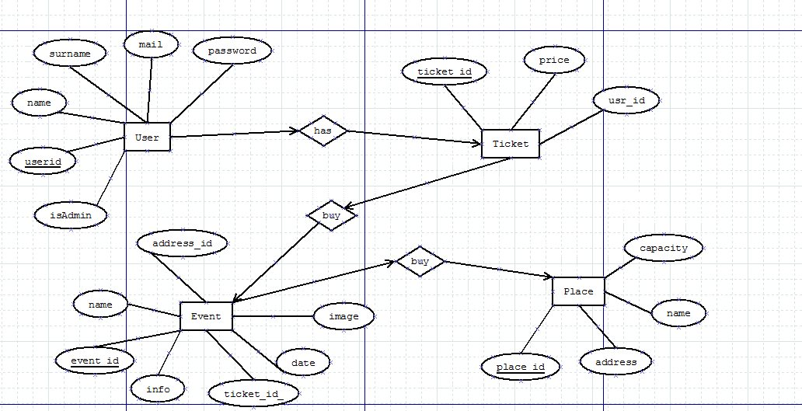

**Output of your web service (xml/json format)**

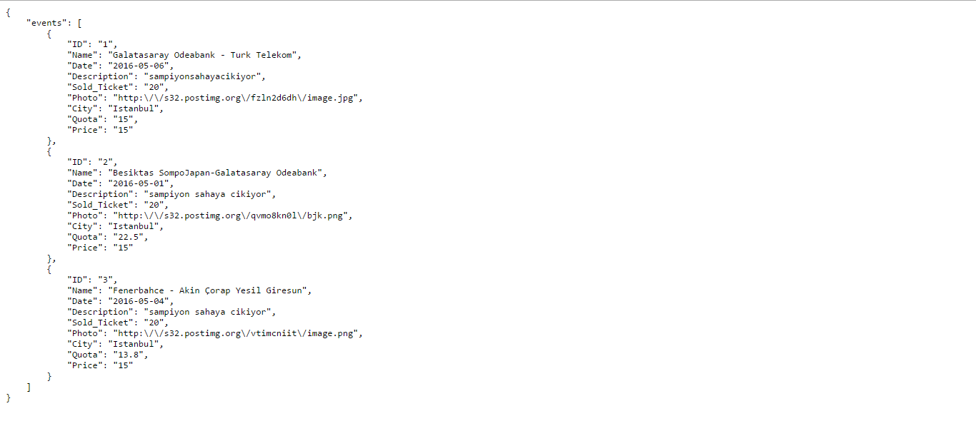

**Web Service Diagram**

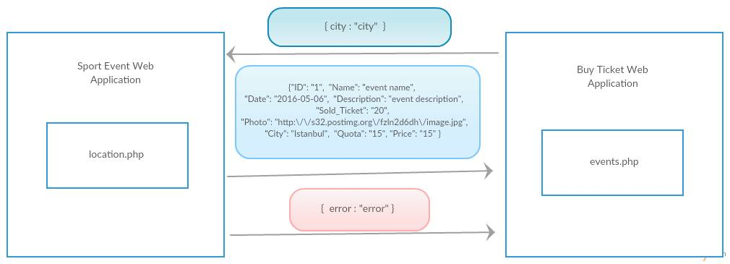

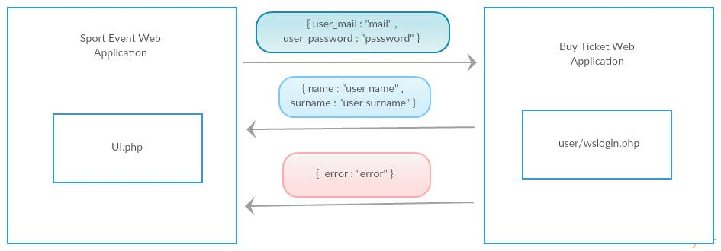

**Screenshots of the project management tool which was taken in different times.**

